英国卡迪夫大学2019年暑期自然科学与工程项目行程安排
Please note this is subject to change.请注意可能有更改。
Saturday 20 July 2019  周六 2019.7.20 | Arrival in Cardiff (Pick up from Heathrow provided)  抵达卡迪夫（提供希思罗机场接机）
Sunday 21 July 2019  周日 2019.7.21 | Networking Event  社交活动
Monday 22 July 2019  周一 2019.7.22 | Welcome Lecture and Orientation Scavenger Hunt  欢迎致辞及迎新寻宝活动
Tuesday 23 July 2019  周二 2019.7.23 | School of Chemistry: Organic Electric Materials  化学学院：有机电材料
Wednesday 24 July 2019  周三 2019.7.24 | School of Chemistry: Materials Characterisation  化学学院：材料表征
Thursday 25 July 2019  周四 2019.7.25 | School of Chemistry: Modern Microporous Materials  化学学院：现代微孔材料
Friday 26 July 2019  周五 2019.7.26 | School of Engineering: Characterizing materials with microwaves  工程学院：用微波表征材料的特性
Saturday 27 July 2019  周六 2019.7.27 | Field trips and free time  实地考察和自由时间
Sunday 28 July 2019  周日 2019.7.28 | Free time  自由时间
Monday 29 July 2019  周一 2019.7.29 | School of Engineering: Compound semiconductors in a world of communications  工程学院：通讯世界的复合半导体
Tuesday 30 July 2019  周二 2019.7.30 | School of Engineering: Damage detection in advanced materials using acoustic emission  工程学院：使用声发射的高级材料的损坏检测
Wednesday 31 July 2019  周三 2019.7.31 | School of Physics and Astronomy: Compound Semiconductor Physics  物理和天文学院：复合半导体物理学
Thursday 1 August 2019  周四 2019.8.1 | School of Physics and Astronomy: THz Physics and Metamaterials  物理和天文学院：太赫兹物理和超材料
Friday 2 August 2019  周五 2019.8.2 | School of Physics and Astronomy: Diamonds, Magnetics Materials and Optoelectronics  物理和文理学院：钻石，磁学材料和光电子学  Final Assessment  结业测试  Final Gala Dinner  结业业晚会晚宴
Saturday 3 August 2019  周六2019.8.3 | Departure from Cardiff (Drop off at Heathrow provided)  离开卡迪夫（提供希斯洛机场送机）
费用：1995英镑
Contact us联系我们
如果您有任何问题或更多信息，请发送电子邮件至angelacs@foxmail.com
手机/微信：13263461779
欢迎关注微信公众号-卡迪夫之夏，了解卡迪夫暑期课程的全部内容。

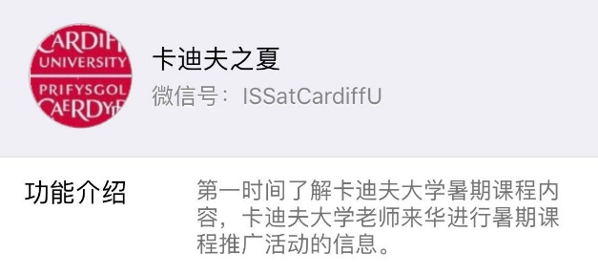 | 